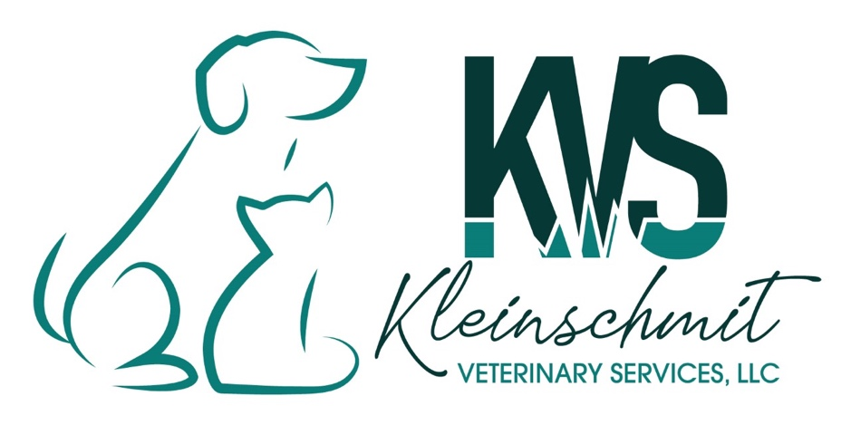

AUTHORIZATION FOR EUTHANASIA
Client Name: ____________________________________________________________________________
Address:________________________________________________________________________________
City: ____________________________________ State: _______ Zip: __________________________
Home/Cell Phone: _____________________________ Alternate Phone: __________________________
Animal Name: _____________________________________ Species: DOG CAT Sex: MALE FEMALE
Breed: ___________________________________________ Color: ________________ Age: _________

I, the undersigned, certify that I am the owner, or duly authorized agent for the owner, of the animal described above. I do herby give Kleinschmit Veterinary Services, LLC and it’s veterinarian complete authority to euthanize and dispose of the animal described above. I release Kleinschmit Veterinary Services, LLC and it’s veterinarian from any and all liability for euthanasia of said animal.
I understand that euthanasia involves administering an intravenous injection of sodium pentobarbital causing painless and irreversible death of the animal described above.
I certify, to the best of my knowledge, the above-described animal had not bitten or scratched any person or animal during the last ten (10) days and had not been exposed to rabies.

Signature:____________________________________________________ Date: _________________
CIRCLE ONE: PRIVATE CREMATION GROUP CREMATION HOME BURIAL

